

**Message of NA: *“…that an addict, any addict, can stop using drugs, lose the desire to use, and find a new way to live.***

***Our message is hope and the promise of freedom.”***

**Primary Purpose*: “…to carry the message to the addict who still suffers…” Basic Text - 6th Ed. - Pg. 68***

DC LINK

April

2021

**C&P Region of NA phone line: 800-543-4670**

1

***STEP 4***

***“We made a searching and fearless moral inventory of ourselves.”***

***Searching and fearless: Step Four calls on us to be searching and fearless. We are asked to look carefully at ourselves and to get beneath the self-deceptions we have used up to now to hide the truth from ourselves. We search within, as if entering a dark house with a single candle to guide us. We move ahead, despite our fear or resistance to the unknown. We need to be willing to illuminate every corner of every room of our minds as if our lives depend on it, because they do. What we are searching for here is a complete and total picture of ourselves. We have found that this requires honesty—honesty to examine our behaviors, feelings, thoughts, and motives, regardless of how unimportant they may appear. Our self-honesty is most important since it will lead us to discover how our disease has affected our lives. We have operated with a distorted self-image, never fully looking at the whole picture all at once. Now, possibly for the first time in our lives, we will begin to see ourselves as we really are, rather than as we imagined or fantasized. The more accurate and complete this picture is, the more freedom we will gain.***

***Moral inventory: In Step Four we are asked to take a moral inventory. When we first heard the word moral, some of us had misconceptions of what that meant, while others had no understanding at all. Morals are simply values, the principles that we choose to live by today in our recovery. It is not the purpose of this guide to define morality nor to define a set of morals that others should live by. We recognize that each of us possesses our own internal values. We may choose to define good as that which has the power to bring out the best in us and affirm our recovery and bad as that which has the power to bring out the worst in us and works against our recovery. Looking at our feelings can be very helpful here too. In writing our Fourth Step, we will need to take a look not only at what we did, but also at how we felt. Our morals may have been vague or undefined, but even in our active addiction we had them. In situations where we felt bad, or felt that something was wrong, it was most likely because we compromised our morals or were unable to uphold them.***

***Of ourselves: It is important to remember that this is our inventory. It is not a place to list the faults or wrongdoings of others. When we look at our lives in this way, we see that the nature of our wrongs, our character defects, are the characteristics in our lives that are in opposition to spiritual principles. Our inventory, then, is a process of discovering how our character defects bring not only us, but also others, pain and discomfort and how our new life, founded on the Twelve Steps, is one that can bring us serenity, comfort, and joy. Out of the Fourth Step we discover those things that get in our way and those things that work for us.***

***General guidelines When we are ready to begin, we ask God to help us to be searching and fearless in this inventory. Some of us even write a prayer at the beginning of our inventory. The important point is that we sit down and start writing. As feelings surface we must be willing to face them and keep writing. Some of them may be uncomfortable or disturbing, but no matter what happens, we know that God is with us. We can feel good about the fact that we are taking positive action for our recovery. We then ask a loving God to help us, and try to remember that what we write is between ourselves and the God of our own understanding.***

***In looking at our behavior before, during and after active addiction, patterns begin to emerge. The purpose of a searching and fearless moral inventory is to get at the truth, to take a hard look at reality. What we are attempting to do here in the Fourth Step is not only to see where we were wrong, but to understand what our part was and how we might be perpetuating those patterns. It is this discovery and identification that allows us to be freed of our defects in the subsequent steps. Although it may sometimes be embarrassing or even painful to be honest with ourselves about our wrongs and character defects, simply writing this information down cannot hurt us.***

***Reprinted from na.org***



***TRADITION 4***

***"Each group should be autonomous, except in matters affecting other groups or NA as a whole."***

***For the purpose of this tradition, "autonomy" can be thought of as a group’s right to independence and self-government - with respect to its own affairs. Just as there is no human authority to govern our membership, neither is there a bureaucracy to supervise our groups. Group autonomy is an extension of the freedoms offered us in NA. The Twelve Steps help us gain freedom from the horrors of our addiction, the perils of our past, and the defects of our character. Autonomy, united with other traditions, helps us maintain our freedoms of membership and expression, collective diversity, and spiritual independence.***

***So long as we continue to rely on the power of a loving God to influence our decisions and their outcomes, we need not establish any codes of conduct for either our groups or our members. This is where the spiritual conscience of a group becomes indispensable. Group conscience authenticates true autonomy, and autonomy works most efficiently when this principle is inclusive to the spirit of our collective Steps and Traditions. Experience has shown us that when adversity strikes a group, and our focus is placed on the solution of our Twelve Steps and Twelve Traditions, the problems solve themselves. In this way, we express our faith in NA as a self-correcting program.***

***Though group autonomy does not justify a disregard for other traditions, neither does it justify retaliation, if perceived that the group has deviated. In this instance, it is imperative that we understand this important concept - complimenting each groups’ autonomy, is each groups’ right to be wrong. If our traditions were enforceable, they would no longer say we "ought," they would say you "must." There are no musts in NA, in any absolute sense of the word. Even our Twelve Steps and Twelve Traditions are only suggestions that neither the individual nor the group must strictly adhere too.***

***Many have argued that this philosophy may spell disaster for both the group and even NA as a whole, but they are later astonished when this was not the case. Though some groups have strayed from NA tradition over time, once it begins to affect their members’ personal recovery or NA as a whole, either the group will wither and die, or group opinion will snap it back in line. Even in such a case, a groups’ autonomy is held inviolate.***

***"So then," you might ask, "can a group decide to do absolutely anything they please?" The answer is, restrictively, "Yes, as long as it is in respect to its own affairs." There is only one exception to the near unlimited liberty afforded a group through our tradition of autonomy. The exception is, that their liberty may not be exercised at the expense of severe consequences to any other groups or NA as a whole. It is for this reason that we have developed a service structure encompassing the principle of consultation. Such consultation will often consist of a discussion encompassing all involved, in order to solicit other opinions and reach a fellowship conscience, a conscience which supports both our unity and our primary purpose.***

***The spirit of consultation is not meant to undermine the principle of autonomy, but to be a safeguard against its misuse. If we invite the guidance of a greater consciousness, check to ensure our motives are inventoried, and strive to maintain open-mindedness as both autonomous groups and consulted service bodies, we believe we can then place our trust in the process as we seek viable solutions. Consultation is a method by which we cultivate new thoughts and ideas which can complement our enthusiasm for helping others.***

***Questions have arisen with respect to how far the principle of autonomy can be exercised in our fellowship. The answer is simple, it is expressed in the wording of this tradition; the freedom of autonomy is limited only to the groups. Our groups, however, have organized service boards and committees to facilitate tasks, which intern frees them to carry the message directly to the addict. These service boards and committees are not NA, as such. They exist solely to serve the groups and neither do they derive authority from their service, nor do they inherit the sovereignty of the groups’ autonomy.***

***In the end, so long as the autonomy of our groups is focused on carrying the message of hope and freedom found in Narcotics Anonymous and our efforts are exercised within the boundaries of our Twelve Steps and Twelve Traditions, the spirit of this tradition will always ring true. As our groups grow and find new and effective ways of helping others, our diversity is then strengthened, broadening our base, and raising our point of our freedom.***

***Reprinted from nawol.org***

2



***CONCEPT 4***

***"Effective leadership is highly valued in Narcotics Anonymous.***

***Leadership qualities should be carefully considered when selecting trusted servants."***

***The trust necessary to confidently delegate service authority is founded on the careful selection of trusted servants. In the following paragraphs, we highlight a number of the qualities to be considered when choosing our trusted servants. No leader will exemplify all these qualities; they are the ideals of effective leadership to which every trusted servant aspires. The more we consider these qualities when selecting NA leaders, the better our services will be. Personal background and professional or educational qualifications, though helpful, do not necessarily make for effective leadership. When selecting trusted servants, after all, it is the whole person we trust, not just their skills. And one of the first things we look for when selecting trusted servants is humility. Being asked to lead, to serve, to accept responsibility, is a humbling experience for a recovering addict. Through continuing to work the Twelve Steps, our trusted servants have come to know not only their assets but their defects and their limitations. Knowing that, they have agreed to serve our fellowship to the best of their ability, with God’s help. Good NA leaders do not think they have to do everything themselves; they ask for help, advice, and direction on a regular basis.***

***Our fellowship’s leaders ought not be dictators or order-givers; they are our servants. Able leadership in the spirit of service does not drive by arrogant mandate, demanding conformity; it leads by example, inviting respect. And nothing invites us to respect our trusted servants more than clear evidence of their humility. Capable NA leadership exhibits the full range of personal characteristics associated with a spiritual awakening. We depend on those who serve us to report on their activities completely and truthfully. Our leaders must have the integrity needed to hear others well, yet still be able to stand fast on sound principle; to compromise, and to disagree without being disagreeable; to demonstrate the courage of their convictions, and to surrender. We seek trusted servants who are willing to expend their time and energy in the diligent service of others, studying available resource materials, consulting those with greater experience in their field of responsibility, and carefully fulfilling the tasks we’ve given them as completely as possible. Honesty, openmindedness, and willingness, indispensable in recovery, are also essential to leadership. Any NA member can be a leader, and every NA member has the right to serve the fellowship. Effective NA leadership knows not only how to serve, but when it will serve best to step aside and allow others to take over. An entrenched bureaucracy inhibits our fellowship’s growth, while a regular influx of new leadership, balanced by continuity, inspires NA growth. The effective leader also knows that, in order to maintain the distinction in service between principles and personalities, it is important to observe the practice of rotation. In some positions, trusted servants need specific skills in order to act as effective leaders.***

***The ability to communicate well can help our trusted servants share information and ideas, both in committee work and in reporting to those they serve. Organizational skills help trusted servants keep small service responsibilities simple, and make straightforward even the fulfillment of complex tasks. Leaders capable of discerning where today’s actions will take us, and of offering us the guidance we need to prepare for the demands of tomorrow, serve Narcotics Anonymous well. Certain educational, business, personal, and service experiences may suit a recovering addict more to one type of service commitment than another. We do ourselves, our fellowship, and our trusted servants a disservice when we ask our members to perform tasks they are incapable of fulfilling. When we carefully consider the leadership qualities of those we ask to serve, we can confidently give them the room they need to exercise those qualities on our behalf. We can allow effective leaders freedom to serve, especially when they demonstrate their accountability to us, reporting regularly on their work and asking, when necessary, for additional direction. True, our leaders are but trusted servants, not governors; yet we also expect our trusted servants to lead us. If we select them carefully, we can confidently allow them to do so. Effective leadership is highly valued in NA, and the Fourth Concept speaks of the qualities we should consider when selecting leaders for ourselves. However, we should remember that the fulfillment of many service responsibilities requires nothing more than the willingness to serve. Other responsibilities, while requiring certain specific skills, depend for their fulfillment far more heavily on the trusted servant’s spiritual maturity and personal integrity. Willingness, spiritual depth, and trustworthiness are strong demonstrations of the kind of leadership valued most highly in Narcotics Anonymous. We should also remember that NA’s leaders are not only those we vote into office. Opportunities for selfless service arise wherever we turn in Narcotics Anonymous. NA members exercise personal leadership by helping clean up after a meeting, taking extra care to welcome newcomers to our fellowship, and in countless other ways. As recovering addicts, any of us can fulfill a leadership role, providing a sound example, by serving our fellowship. This modest spirit of service to others forms the foundation of our Fourth Concept, and of NA leadership itself.***

***Reprinted from na.org***

***NA Recovery Stories***

micheal m. Recovery Story…

I was an only child, the nerdy kid growing up, and didn’t really feel as if I fit in with anyone specific group of people. I wanted to be accepted, so I started hanging out with the cool kids and partying. It just kind of took off from there. It went from an occasional thing to every chance kinda thing. I went from smoking weed, to smoking [weed](https://www.justthinktwice.gov/drugs/marijuana) and drinking, to doing anything I could get my hands on. I found freedom in getting high and for the first time in my life, I was comfortable. As things progressed with time, I became addicted and fell in love with opiates. I started using [Oxycontin](https://www.justthinktwice.gov/drugs/oxycodone) in 2009 which eventually led to me using [heroin](https://www.justthinktwice.gov/drugs/heroin). My addiction to heroin took priority over everything I did in life. I died a total of 15 times due to drug overdose. One would think that overdosing time and time again would give someone the desire to get clean. In reality, I wanted to die. I absolutely hated the person that I had become as a result of my addiction to drugs and alcohol.

I’ve been arrested numerous times for multiple DUIs, shoplifting, petit larceny, possession, driving on revoked for DUI, and harboring a fugitive from justice. I was on a total path of destruction. I have been in a total of 7 treatment programs and multiple detox centers. Trying over and over to put my life back together.

In April of 2019, I went back to jail on a home confinement violation because I was getting high in another program and I was just tired. For the first time in my life, I felt completely defeated. So, when I went in in April, I surrendered and turned to God for help. I was ready for a different direction in life and was tired of doing the same thing over and over. I was tired of hurting people, hurting family, and not being able to be a dad because addiction ran my life. I decided at that point that if I was given another opportunity to try to put my life back together that I was going to take it and run with it.

I did about 130 days in jail and was given yet another opportunity to change my life. I entered a long term treatment program with Recovery Point and began my journey in changing my life. Today I have over 9 months completely substance-free. Everything changed for me this time around, I had the gift of desperation and was willing to do whatever was asked of me in order to achieve long term sobriety. I remember laying in jail, praying for God to help me, and absolutely willing to do whatever it took for a new direction in life. Instead of viewing it as a consequence, I viewed it as an opportunity.

TODAY: I have been given my life back. I am rebuilding relationships with my family. I am rebuilding trust. I am able to be a dad today and a positive influence in my son’s life. I continue to work towards cleaning up the wreckage of my past. I’m a Recovery Coach and can be a point of light in a world of darkness and watch others transform as they find their purpose in life.

There is a way out. It is not easy, but at the end of the day, it is worth it. There is a lot more to living life than to get up and to worry about putting the next one in you. No matter what, at the end of the day, the reality is still there. It is something that you have to face. It is just a matter of trying to reach out for help and get guidance on how to face it. There is freedom in the fact that you can wake up every day with a clear conscience that you did not deliberately harm somebody the day before for selfish benefit. Today, I strive to be a light of hope and have the ability to share my own personal experience with others in hopes of leading others towards a better way of life.

MICHAEL W

REPRINTED FROME: justthinktwice.gov

DC LINK

4

DC LINK

RECOVERY HUMOR

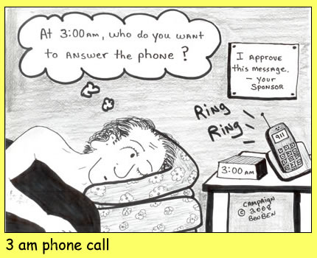

Ben C.

Ben C.

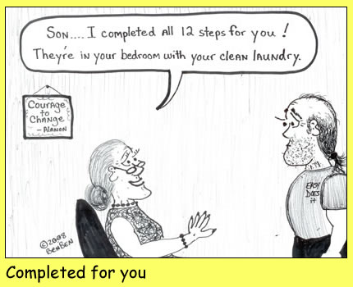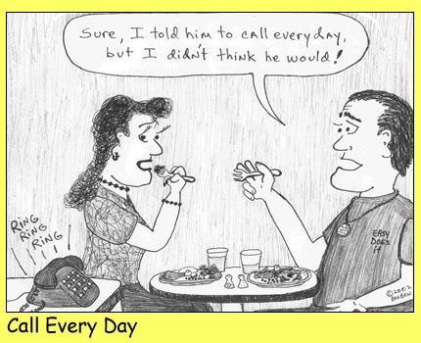

Ben C.

Ben C.

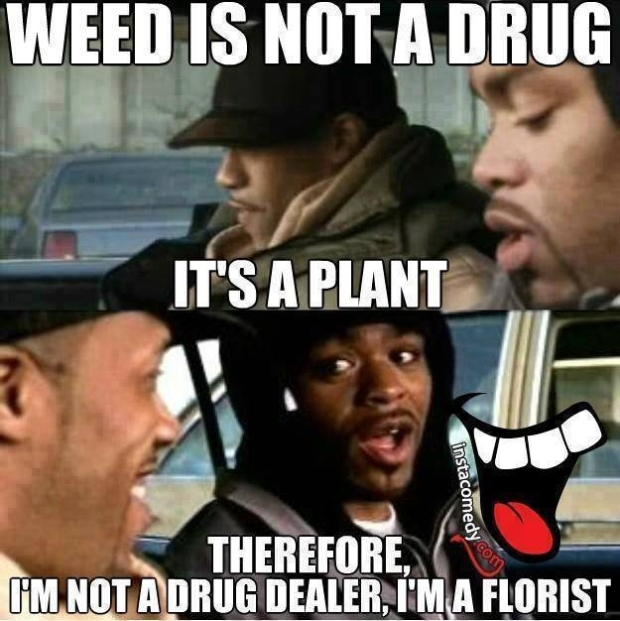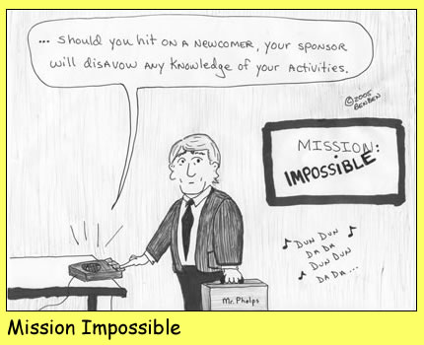

5

Ben C.

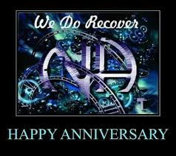

***Acknowledgements:***

***Monica R will acknowledge. 22 years 4/16/2021***

***Anniversary's***

***TONY F celebrates 26yrs at Sunday Morning Spiritual Sun 4/4@9am ID: 812 2295 5124 PW: 774257***

***JOE A celebrates 4yrs at Monday Night Step Mon 4/5@7:30 ID: 457 476 3595 PW: MNS***

***ERNESTINE Y celebrates 5yrs at One Step At A Time Fri 4/9@7pm ID: 492 355 108 PW: 349943***

***SAUNDRA S (sassymomma) celebrates 17yrs at 818 Miracles Sat 4/10@7pm ID: 7311 4984 304 PW: 818***

***RITA F celebrates 33yrs & LEVIN P celebrates 32yrs at 10:30 Coffee Hour Sunday 4/11@10:30 ID: 849 7022 7938 PW: 930969***

***ERIC P celebrates 32yrs at It Works How And Why Mon 4/12@7pm ID: 623 606 6098 PW: 010746***

***RICK T celebrates 14yrs at Ultimate Weapons Wed4/14@7pm ID: 516 993 416 no pass***

***JOE celebrates 3yrs at NA In Delray Sun 4/18@10am ID: 873 4446 3412 PW: 1991***

***LEO R celebrates 2yrs at NA IN Delray Tues 4/20@7pm ID: 533 129 809 Pass: NALA***

***ALLISON K celebrates 5yrs at NA For Life Fri 4/23@7pm ID: 813 4054 8864 PW: LIFE***

***ERIC J celebrates 27yrs at Aging In Recovery Fri 4/23@7pm ID: 824 005 5286 Pass: recovery***

***CEDRIC C celebrates 16yrs at Living Life On Life’s Terms Sat 4/24@8pm ID: 438 3483 469 PW: 121525***

***KHADIJA D & TAMMY B both celebrate 29yrs at 10:30 Coffee Hour Sunday 4/25@10:30 ID: 849 7022 7938 Pass: 930969***

***PERMANENT ADDICT PAUL celebrates 31yrs at Monday Night Step Mon 4/26@7:30 ID: 457 476 3595 PWs: MNS***

***DC Link March 2021 Anniversaries &***

***Acknowledgements… Congratulations All!***

***April*** ***2021***

******

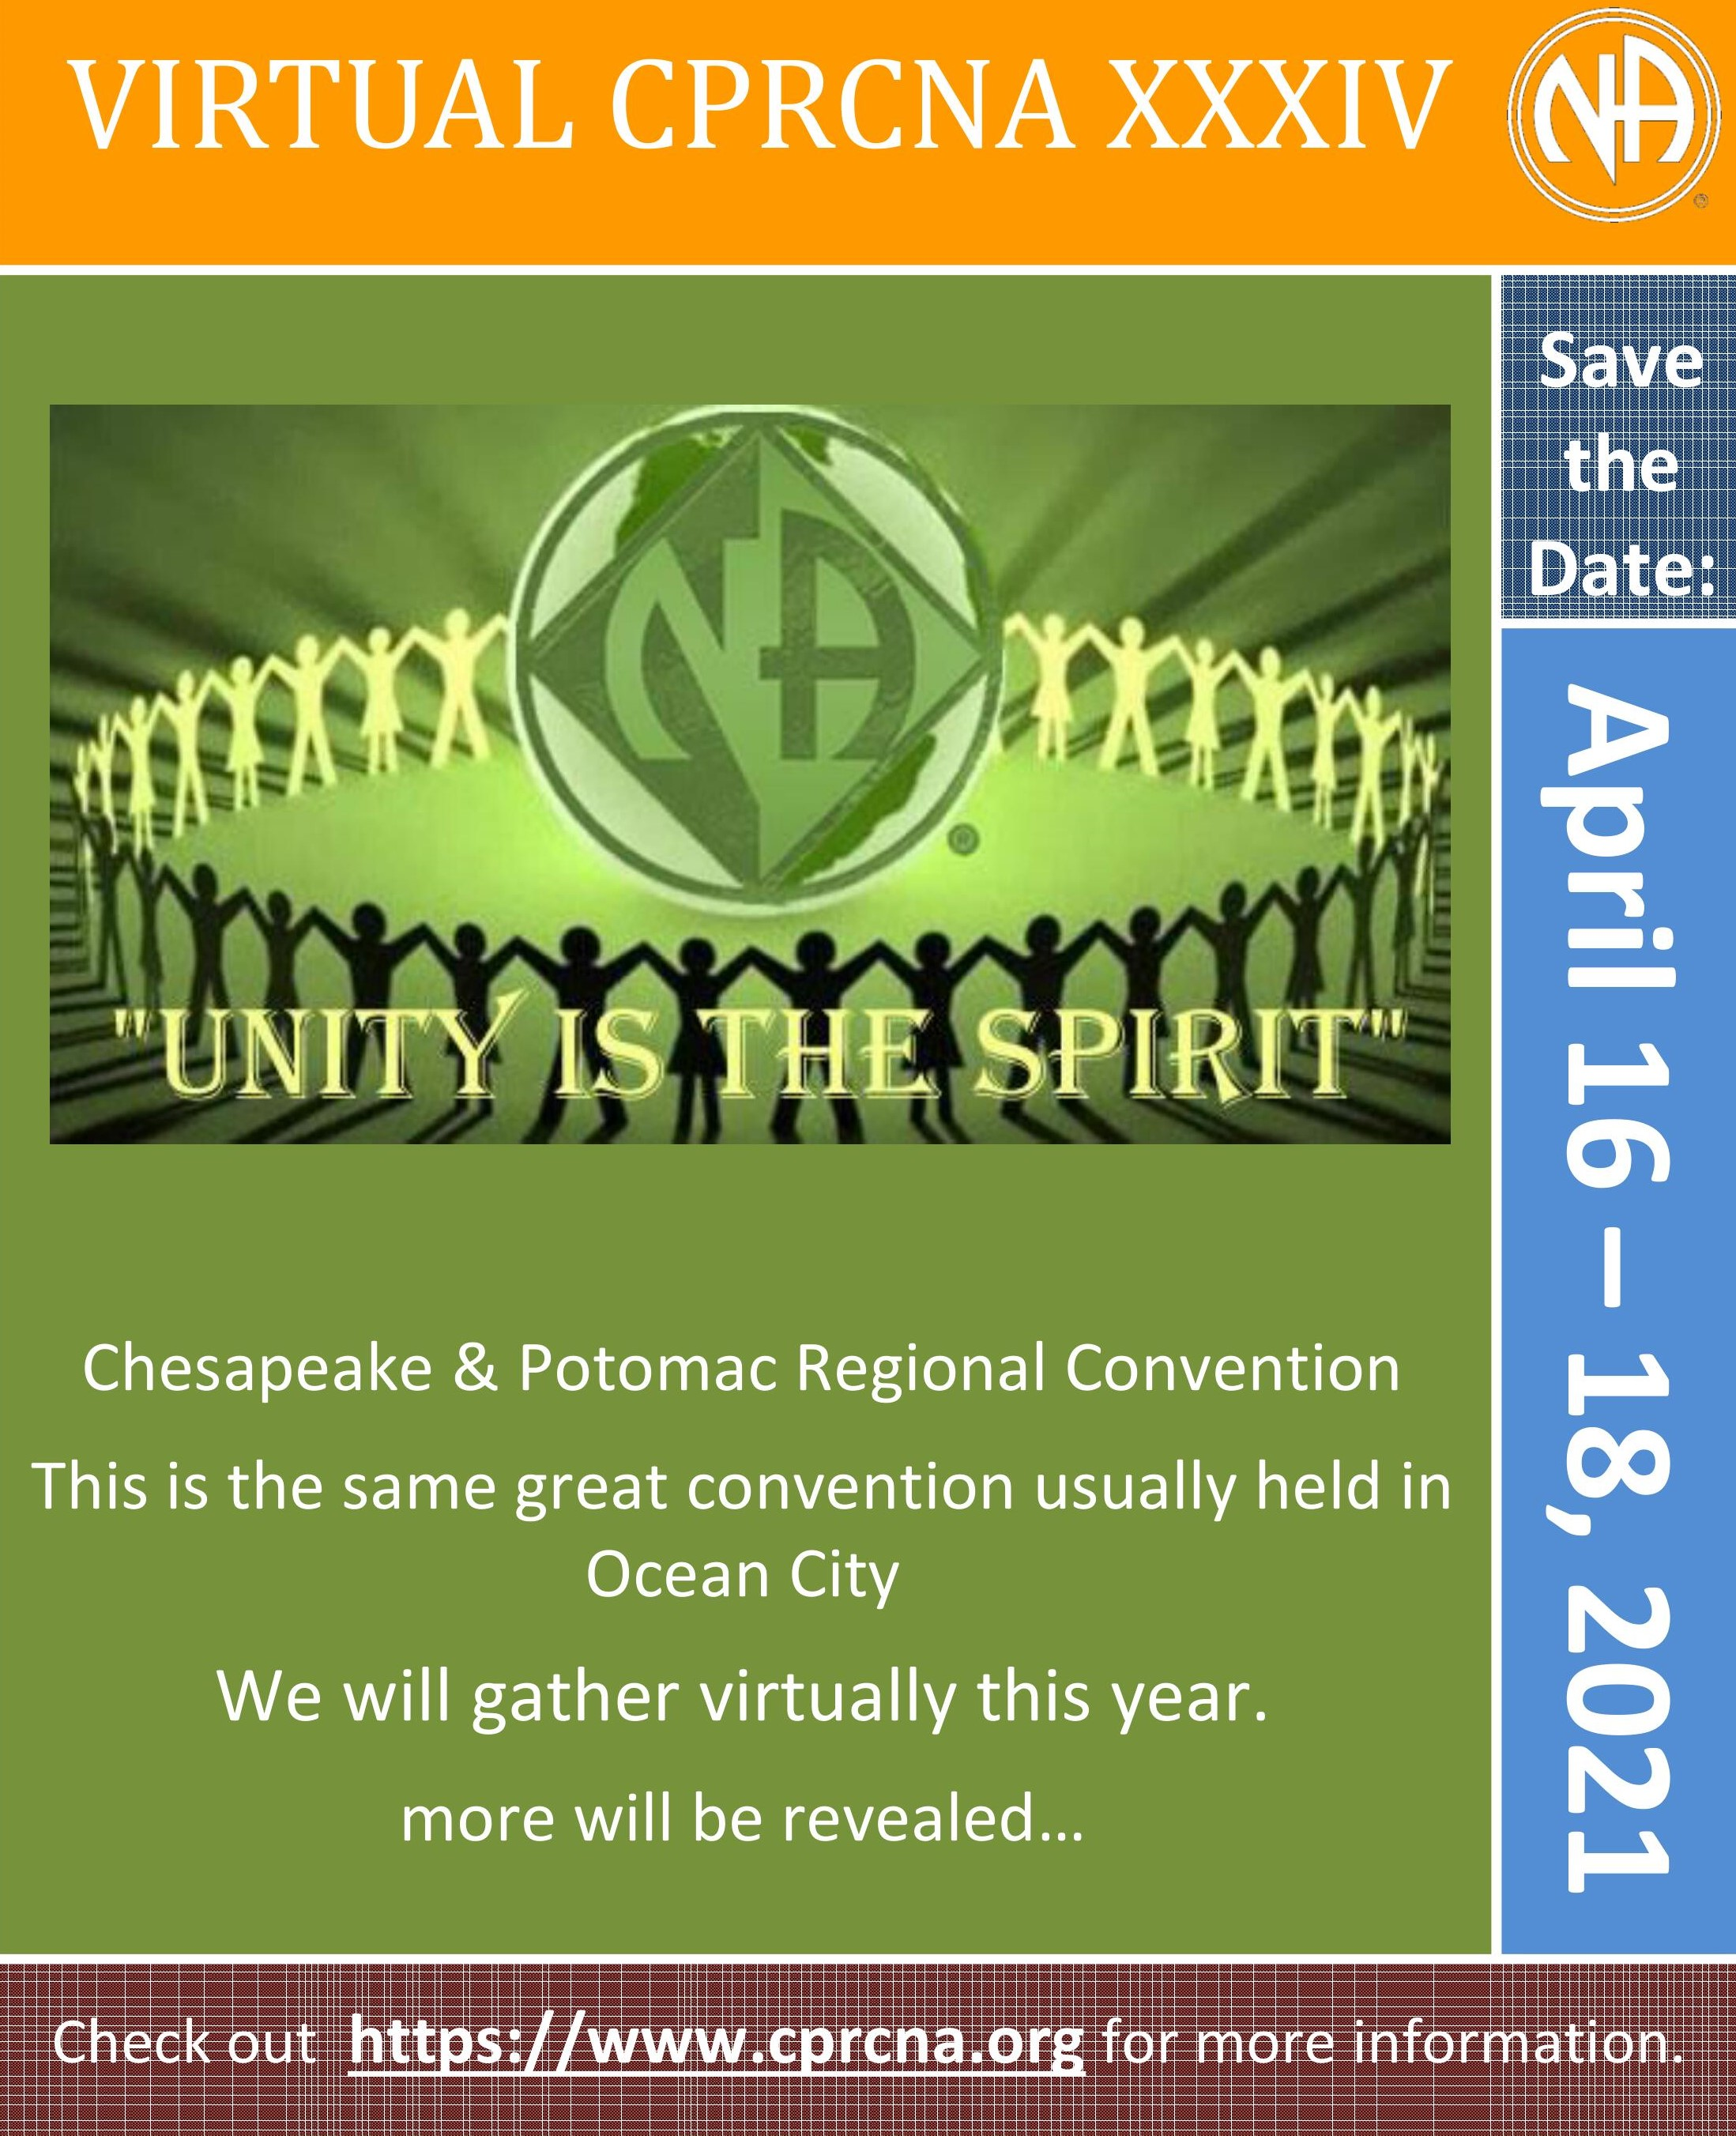

***DC Link NA EVENTS***

7

DC LINK NA EVENTS cont...

8



*DC AREA SERVICE*

Meets 1st Saturday of every month  
 Westminster Presbyterian Church

400 I St. SW

Admin. Body meets at 10:45am

Full body meets at 12 noon

*Names of newly elected DCASC*

*trusted servants will be posted in*

*September newsletter*

Chair: Joan H.

Vice Chair: Open

Secretary: Pam C.

Asst. Secretary: Vicki

RCM: Shirley B.

RCM ALT: Open

Treasurer: Tecoy W.

Asst. Treasurer: Open

COC Rep. William W.

DC Area Rep. to CPRCNA Program

Sub Committee: Open

DCASC Subcommittees:

Hospitals & Institutions (H&I)

Meets 4th Sat. at 116 T St. NE 3:00pm   
 Main Conference Room

Chair: Sranda W.

Vice Chair: OPEN.

Special Events

Meets 3rd Sat. of every month at

Dorothy Heights Library 10:00am

Chair: Rhoda N.

Vice Chair: OPEN

Newsletter

Meets 3rd Mon. of every month at

Lamond Riggs Library 6:00pm

5401 South Dakota Ave NE  
 Chair: Tammy F.

Vice Chair: OPEN

Literature   
 Meets TBD  
 Westminster Presbyterian Church

400 I St. SW 10:30am

Chair: Valencia H.

Vice Chair: Luther L.

Policy

Meets 3rd Tues. of every month

at Plymouth Congregational

United Church of Christ 6:30pm   
 5301 North Capitol St NE   
 Chair: James T.  
 Asst. Policy Monitor: Charles N.

Public Relations (PR)

Chair: Open

Vice Chair: OPEN

DC LINK

***DC Area NA meetings are held virtually or closed until further notice!***

**Many of the Chesapeake & Potomac Region’s NA meeting**

**have created virtual or phone meetings or have temporarily cancelled**

**due to the Coronavirus pandemic.**

**For Virtual Meeting Information Go To:**

**https://www.cprna.org/na-meetings/**

**To Access Our DC Link Newsletter, Go To:**

 **https://www.cprna.org/our-areas/news/district-of-columbia-area/**



**-DISCLAIMER-**

***The “DC Link” is the monthly newsletter of the DC Area Service Committee. Its purpose is “carrying the message of recovery and increasing unity”. The opinions expressed here do not necessarily reflect the views of Narcotics Anonymous as a whole. No endorsement of, or affiliation with any organization is intended or implied. Reprint rights are granted to all service boards and committees of NA. Submissions from* *members are eagerly welcomed, but the newsletter subcommittee reserves the right to return or*** ***edit.***

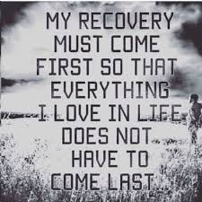



9